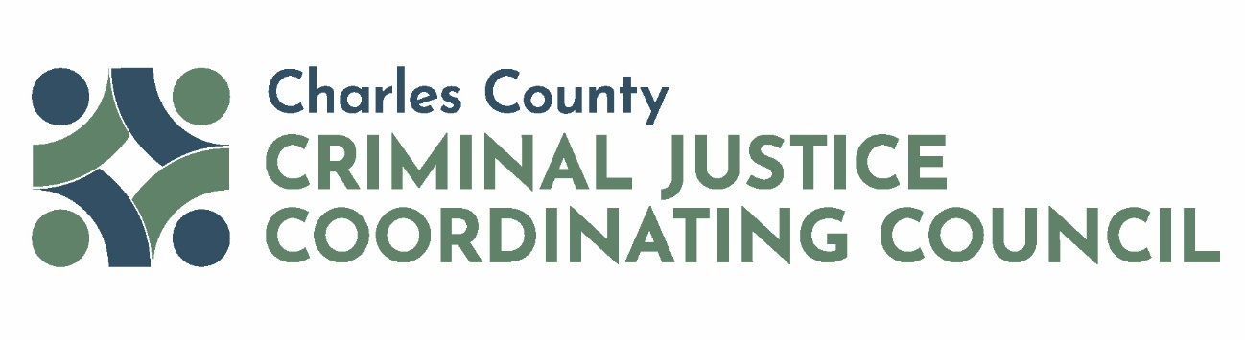

Full CJCC Meeting
Date | Time: 9/4/2025 8:00 AM to 9:00 AM
Location: Microsoft Teams Virtual Meeting
Meeting Co-Chairs: Hon. H. James West and Commissioner President Reuben B. Collins, II, Esq.

Meeting Objectives:
- Approve Meeting Minutes from July 2025
- Presentation – Life After Release
- Provide Updates – Pretrial Services Sample Budget, CIM, Request Volunteers for CJCC Operations Committee, Next CJCC Meeting
- Open Discussion

Agenda Items
- Welcome CJCC Co-Chairs
- Approve Meeting Minutes CJCC Co-Chairs
- Presentation – Life After Release McKayla Wilkes, Community
Outreach Organizer for Life After
Release

- Updates CJCC Staff
- Open Discussion CJCC Members
- Adjourn

The mission of the CJCC is to enhance the operation of the Charles County adult and juvenile justice systems through interagency collaboration and the coordination of cohesive policies and programs for the purposes of improving public health and safety and heightening public trust.

