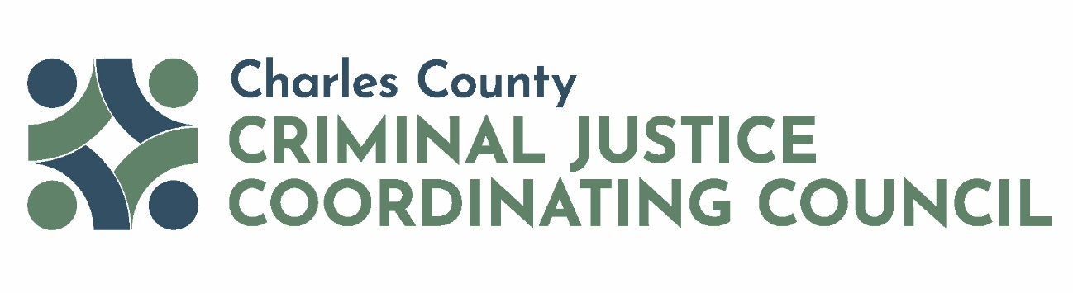

Full CJCC Meeting
Date | Time: 5/1/2025 8:00 AM to 9:00 AM
Location: Microsoft Teams Virtual Meeting
Meeting Co-Chairs: Hon. H. James West and Commissioner President Reuben B. Collins, II, Esq.

Meeting Objectives:
- Approve Meeting Minutes from March 2025
- Presentation – Critical Intervention Mapping
- CJCC Committee Updates
- Open Discussion

Agenda Items
- Welcome CJCC Co-Chairs
- Approve Meeting Minutes CJCC Co-Chairs
- Presentation – Critical Intervention Mapping Kathleen Kemp, Ph.D., National Youth Screening & Assessment
Partners, LLC

- CJCC Committee Updates CJCC Committee Chairs
- Open Discussion CJCC Members
- Adjourn

The mission of the CJCC is to enhance the operation of the Charles County adult and juvenile justice systems through interagency collaboration and the coordination of cohesive policies and programs for the purposes of improving public health and safety and heightening public trust.

