
Mattawoman Watershed Society

Protecting and preserving Mattawoman Creek for the enjoyment of all.

Steven Ball, Director February 4, 2015
Dept. of Planning and Growth Management BallSt@charlescountymd.gov
200 Baltimore Street
La Plata, MD 20464

Re: Maryland Airport Land-Use Study

Dear Mr. Ball:

The Mattawoman Watershed Society (MWS) is pleased to offer these comments on the land-use study being conducted for the area around Maryland Airport. Because MWS is focused on maintaining the health of Mattawoman Creek for our nearly 2000 supporters, most of whom live in Charles County, we take great interest in this ecologically sensitive area. Consequently, we have provided a stakeholder interview and follow-up information to the consultants, Environmental Resources (ERM). Our board and many other members also attended the January 14 Open House, but were unable to testify because of time constraints imposed by the hosting facility before their names were reached on the sign-up sheet.

Land-use is a critical concern for the health of Mattawoman because its watershed is under intense development stress. Since the invention of the Development District in 1990, Mattawoman has declined from a state with “near to ideal conditions” [DNR, 1992] to one at the “tipping point” for irreversible degradation. [Task Force, 2012] In particular, the abundance, species richness, and trophic structure of the estuarine fish community have all declined, and anadromous fish spawning intensity in the nontidal river has plummeted. The river now exhibits an altered hydrological regime, and the spatial gradient of electrical conductivity (indicative of road salts) has reversed direction from the historical record, now actually increasing as one proceeds upstream from head of tide. [DNR, 2010; 2011; 2013]

For over 70 years, the privately owned Maryland Airport has occupied a plateau severely constrained between the Mattawoman stream valley and Bryans Road. Now, after the filling of a stream valley with “devastating impacts” [NMFS, 2001], it is anticipated that the runway will be lengthened to 4300 feet if a supplemental Environmental Assessment is approved. The lengthened runway has prompted development interests to seek county-provided infrastructure for greenfield development in a large forested area around the airport. Hence, language was inserted into the draft Comprehensive Plan calling for the present land-use study, with one objective being to “[e]xplore the potential for return on investment to extend sewer lines to the area, including the Indian Head Science and Technology Park.” [RFP, 2013]

In fact, an airport overlay zone makes sense if approached objectively and with modern smart-growth planning principles in mind. Here we examine the objectives of the land-use study as they were given in the Request for Proposals, where the objectives appear in their most complete form. [RFP, 2013] Based on this analysis, we find that the land-use study should recommend conservation measures in such an overlay zone, rather than promoting the industrialization of ecologically sensitive forestland.

Land-Use Study Objective A. Protect public health, safety, and welfare through the adoption of land-use standards that minimize the public’s exposure to safety hazards and excessive noise from the airport.
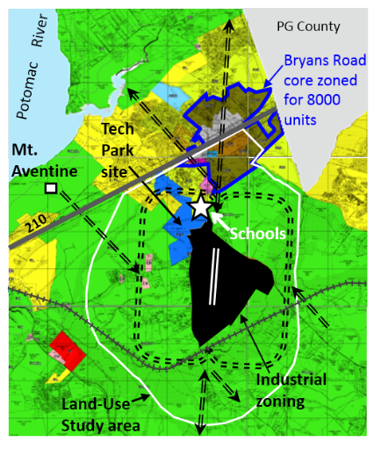
Fig. 1 Zoning map. Solid colored areas call out PEP (blue) and combined BP and IG zoning (black). Bryans Road core is outlined. Double dashed-lines show standard FAA left-hand flight patterns tied to the runway location and orientation (double white lines).
Residential development is generally considered incompatible with airport operations due to concerns over noise, safety, and air quality. The location of the Maryland airport makes expansion of operations problematical in this regard.

If the Supplemental Environmental Assessment (EA) is approved in spite of segmentation concerns expressed by the EPA, air traffic can be expected to increase. Official projections for the increase in aircraft operations fail to account for the expected jump due to the runway extension. Instead, both the original EA and a 2008 Aviation System Plan [MAA, 2008] project a steadily rising increase of 500 flights per year. However, the press reports the prediction of a stunning fourfold increase due to gambling traffic. [Independent, 2013] In any event, substantial increases in aircraft operations are predicted over time. Hence Objective A and Objective B (prevent incompatible encroachment) assume great importance. An overlay zone that prevents residential development should be considered.

In addition, the new runway orientation is incompatible with the previously adopted but controversial Bryans Road sub-area plan. The plan contains a dense core zoned for 8000 housing units directly beneath the new northern direct-flight path (see Fig. 1). This core is far from built-out. Therefore, to alleviate this incompatibility, the Land Use Study, being a component of the Comprehensive Plan, should recommend that Bryans Road be returned to a mixed-use village status to avoid incompatibly with a densely zoned core beneath the flight path.

We note that our recommended downscaling of Bryans Road as a protective “land-use standard” was also contained in the compromise “merged” comprehensive-plan scenario produced by the public process in 2011, but later rejected by the Planning Commission that has since had major turnover in members. At the time, the Merged Scenario did not consider safety and public welfare vis a vis the airport, but rather reflected smart-growth concerns, such as maintaining rural character and focusing growth where rail or bus rapid transit is feasible and redevelopment opportunities abound (e.g. the Waldorf Urban Redevelopment Corridor). The airport Land Use Plan is an opportunity to recommend that Bryans Road be configured as a mixed-use village centered on the Safeway shopping center, as was once intended, to again comply with smart-growth principles and to satisfy the goals of Objectives A and B.

The MWS has interest in promoting outdoor education, and regards the location of the two schools within the flight path (see Fig. 1) as an issue. In particular, the noise of aircraft operations will likely interfere with outdoor classroom activities and should be minimized. Flight restrictions should be considered to reduce air traffic during school hours on the crosswind leg of the flight pattern that is operative during northerly winds (i.e. the north segment of the western rectangular flight-pattern in Fig. 1).

Land-Use Study Objective B. Prevent the encroachment of incompatible land uses around the airport in order to preserve the future utility of the airport.

A number of issues related to Objective B have been covered under Objective A. For example, the dense urban core in Bryans Road, if it continues to invite 8000 housing units, represents an encroachment issue.

The building density, and the small setbacks along Route 210 promoted by the sub-area plan for Bryans Road, have also been discussed as an encroachment issue for the Naval Support Facility in Indian Head, because energetic material are transported on Route 210, and high densities along the highway increases risk. [JLUS, 2014a]

To summarize the Bryans Road issue, returning Bryans Road to a mixed-use village would have the following benefits: (i) removes a serious encroachment problem; (ii) removes an incompatible land-use designation; (iii) reduces encroachment on the Navy’s transport of energetic materials on Route 210; (iv) returns to a smarter growth vision; (v) achieves consistency with the withdrawal of the Cross County Connector.

Residential development, one option proposed by the recent tech-park market study [JLL, 2014], should be avoided to be consistent with Objective B. Conservation of this area is consistent with the objective.

The boundary of the Land Use Study is shaped at the northeast to specifically avoid consideration of the Guilford subdivision now up for preliminary-plan approval. Since the tract is proposed for 438 housing units, the exclusion is curious. The Land Use Plan should consider the ramifications of this large number of units in such close proximity to the airport.

The goal of Objective B to prevent incompatible land-use would be satisfied with conservation zoning. Further, no new areas should be considered for development to protect Mattawoman Creek and because market studies (discussed below) find new lands for new development are not needed.

Land-Use Study Objective C. Ensure the growth of aviation compatible economic development activity within the areas surrounding the airport.

The Open House presentation reported that airport marketing study finds limited opportunities for aviation-related development. Most if not all aviation-compatible activities can occur “inside the fence.” For further related analysis, please see the discussion of Objective F (marketing strategy to promote development).

Land-Use Study Objective-D. Assessment of future growth and development with respect to environmental conditions related to the Mattawoman Creek Watershed.

The cumulative adverse effects of development on aquatic resources are well-recognized in general, and specifically for the Mattawoman, at the “tipping” point for irreversible decline. [Task Force, 2012] In 2008, the Army Corps of Engineers (ACOE) admonished:

“The County cannot rely on State and Federal regulatory programs within their limited scope of review to protect the aquatic resources of the Mattawoman Creek.” [ACOE, 2008]
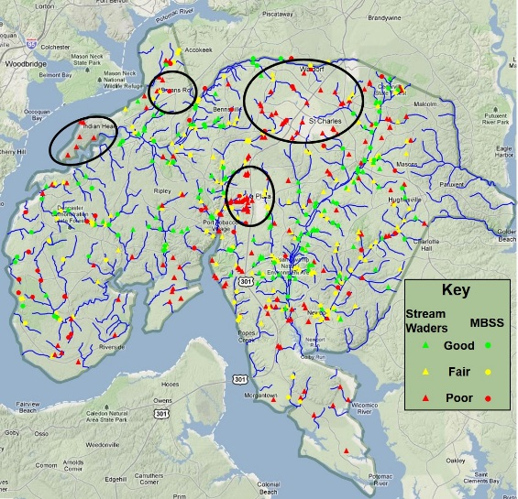
The truth of this statement is manifest in the declining health of the Mattawoman. [DNR, 2010; 2011; 2013; Task Force, 2012] The inability to fully protect against urbanization is evidenced in the clustering of “poor” stream sites in urbanized areas of Charles County, as measured by the index of biotic integrity for benthic organisms (see Fig. 2).

We note that the present lengthening of the runway to 3750 feet has already filled in a Mattawoman stream valley. Extensive comments strongly criticizing the destruction of this stream valley, and expressing deep concerns for the cumulative adverse impacts of airport development, were submitted by the National Park Service, the National Marine Fisheries Council, and the ACOE during the review process. [EA, 2002] Here, we cite only three (emphases added):
Fig. 2 Ranking of stream quality based on surveys of benthic macro-invertebrates through 2011. Note clustering of poor sites in the circled urbanized areas.

NPS: It is our opinion that the proposed airport improvements would cause significant long- term adverse effects to Mattawoman Creek… Such adverse effects would degrade the existing high-water quality. [NPS, 2001]

NMFS: The runway realignment will have devastating impacts on the subject watershed. We are particularly concerned with the destruction of the sloped, forested riparian zone, which will drastically alter instream hydrology… We are also concerned about cumulative impacts this proposal will have on wetlands and instream habitat throughout the local region. [NMFS, 2001]

ACOE: We consider the filling of 900 feel of the headwaters to be a substantial adverse impact to the aquatic environment, and informed Mr. Bauserman of this by letter dated June 11, 2001. [ACOE, 2001]

Charles County stands out for its biodiversity statewide. [BioNet, 2012] The hotspots comprise the Zekiah, Nanjemoy, and Mattawoman watersheds, which stand out in the mid-Atlantic region. [FWS, 2006] The area of the land-use study includes a remarkable number of ecological attributes, many of which were enumerated in the January 14 open-house presentation and appended slides. [ERM, 2015]
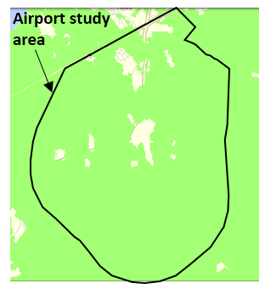
Please note that the entire area is essentially blanketed by state Targeted Ecological Area (see Fig. 3); the TEA was underestimated in the presentation slides due to an obsolete online GIS-layer which has since been corrected; the error has been communicated to ERM.

There are many additional ecological features not listed in the open-house presentation that also merit protection. Many of these have been previously communicated to ERM in greater detail; here we relate those not included in the Open House presentation.
Fig. 3 Targeted Ecological Area (green) [MERLIN]
An especially high-quality stream with headwaters in the site of the failed tech-park. This stream has a preponderance of sites having a “good” benthic index of biotic integrity; strong fish species-richness, including the declining American eel; high water quality; and supports spawning anadromous fish. Details and references are available at an MWS webpage.

Drainage to anadromous-fish spawning reaches of Mattawoman. In recent years, these reaches have exhibited a marked decline in usage by spawning River Herring (Alosa pseudoharengus and Alosa aestivalis) as measured by ichthyoplankton surveys by DNR [DNR, 1975; 2010; 2011; 2013] and by MWS. [MWS, 2000]
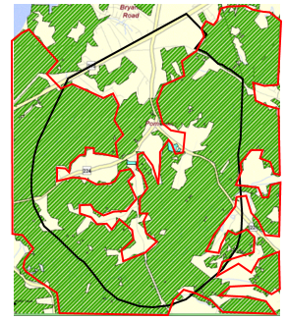
A predominance of green-infrastructure hub and corridor forest, that together are “vital to maintaining the state's ecological health,” and to “[p]reserving linkages between the remaining blocks of habitat [that] will ensure the long-term survival and continued diversity of Maryland’s plants, wildlife, and environment.” (See Fig. 4)

A predominance of Forest Interior Dwelling (FID) habitat. [WRR] (See Fig. 4.)
Fig. 4 Forest hub and corridor (green). Audubon Important Bird Area (red boundary). [WRR; Audubon]
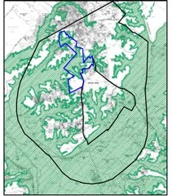
Audubon Important Bird Area: much of the forest has been designated an IBA by the Audubon Maryland-DC chapter based on quantitative criteria applied to ground surveys. [Audubon, 2010] (See Fig. 4.)

Natural stormwater infrastructure, discussed below. [WRR]

Mattawoman Stream Valley, an area that the ACOE strongly recommended for protection [ACOE, 2003], and that was subsequently mapped by the Maryland Department of Natural Resources. [DNR, 2007] (See Fig. 5.)
Fig. 5 Streamvalley to the top of slope delineated by DNR (green). The boundary for land zoned for PEP, BP, and IG is shown.
Steep slopes, e.g., as mapped by the ACOE in Appendix B of the Mattawoman Creek Watershed Management Plan. Note that slopes tend to harbor an increased density of FID bird species. [Audubon, 2002]

The airport has already caused devastating environmental effects. These should not be amplified and spread into sensitive areas. A study recommendation for conservation is strongly indicated by the breadth, quality, and extent of the outstanding terrestrial and aquatic ecological features of the area. Conservation would automatically fulfill objectives A, B, D, F.

Land-Use Study Objective E. Explore the potential for return on investment to extend sewer lines to the area, including the Indian Head Science and Technology Park.

This objective seeks an economic justification for the county to provide sewer lines to the area. Aside from the fact that the objective seems prematurely to assume that the Land Use Study will recommend providing sewer, an understanding of the costs is essential in addressing the objective. Below we recommend that the Land-Used Study also divulge likely costs in addition to sewer lines. Here we address in detail the costs of the sewer lines (~$8 million, not the $1.5 million advertised by development interests at the Open House) and current airport annual revenue (~$1.5 million, not the $9 million advanced by development interests.)

Cost of sewer lines. While we urge conservation for the tech-park site, we base these comments on the premature goal of Objective E to develop the tech-park, and the fact that the tech-park remains in the draft Comprehensive Plan. Based on a 2010 letter to MWS from Edith Patterson, then vice-president of the Board of County Commissioners [Chas. Co., 2010, appended], sewer lines to the tech-park site are envisioned in two phases. The total cost is about $8 million, including bond interest. This estimate employs amounts in the letter, updated by the consumer price index, as follows:

Item | Cost (millions)
Sewer phase 1 as stated in county letter | 1.765
Sewer phase 2 as stated in county letter | 4.236
Subtotal in 2010 $ | 6.001
Subtotal in 2014 $ | 6.515
Total with 3% interest over 15 years | 8.098

Including interest, county estimates total $8 million. We note that the Open House presentation does not appear to show the full extent of possible sewer lines as suggested by the Patterson letter.

Airport revenues. Advocates for industrializing the area around the airport have advertised annual airport revenues of $9 million. The figure is contained in a pamphlet the airport owner distributed at the Open House ($9.276 million), and has been quoted in the press by a past chairman of the Chamber of Commerce. [Independent, 2015] However, the amount is much exaggerated by construction jobs during the runway lengthening.
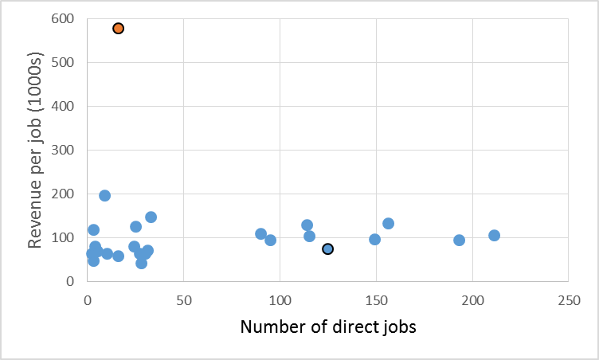
Fig. 6 Blue circles: revenue (in 1000s) per direct-job, derived for airports in Maryland having from 3 to 211 direct jobs in Table 2 of the Maryland Aviation Administration’s economic impact report. [MAA, 2013] Maryland airport is highlighted with a black boundary (125 jobs including those for runway construction). It falls within the normal range for all airports. The orange symbol uses the same revenue of $9.3 million, but scales to 16 jobs, the number in 2012 excluding temporary construction jobs. The extreme placement of the orange marker shows that the MAA report methodology included temporary construction jobs when estimating revenues.
The figure of $9 million originates from Table 2 of Maryland Economic Impact of Airports, a report by the Maryland Aviation Administration (MAA) that compiled statistics from various airports for calendar year 2012. [MAA, 2013] The number of direct jobs in Table 2 of the MAA report is 125. This is very near the number of 122 given in the Open House presentation, which notes that the number includes runway construction-related jobs. The Open House presentation states that the number of airport jobs in 2012 was 16, once construction jobs are excluded. Analysis of Table 2 in the MAA economic report shows that revenue scales with number of direct jobs, with a proportionality of about $93,000 per job (see Fig. 6). Maryland airport, with 125 jobs inflated by construction, falls squarely within this proportionality factor with the other airports (circled blue symbol in Fig. 6). When one uses the more telling number of 16 jobs not including construction, the revenue comes to $1.5 million (16 x 93,000), much less than the $9 million advanced by development interests.

Other costs. The Cross County Connector (CCC) remains in the Comprehensive Plan, as does the “Pomonkey Connector,” listed as a “new road” from MD 227 to the CCC. Both also remain listed in the FY2015 Budget Book, where it is clear that the Pomonkey Connector is proposed specifically to connect to the airport. [Budget, 2015; p. 374] The airport Land Use Study is part of the draft Comprehensive Plan, and thus should acknowledge costs associated with the airport contained therein, such as the Pomonkey Connector. We urge that the Land Use Study recommend these projects be removed from the Comprehensive Plan. Otherwise, it is incumbent on the study to divulge the costs of the Pomonkey Connector as a part of addressing Objective E.

If the study recommends developing the area, we recommend that other public costs that would be incurred by developing the area be explained. Additional public costs can be reasonably anticipated, such as road widenings and increases in the capacity of emergency services. Of course, conservation of the area would eliminated these financial burdens.
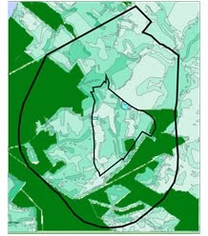
Fig. 7 Natural stormwater infra-structure filters pollution, assists water infiltration, and reduces flooding. Dark green areas are state-preserved lands and were not analyzed. [WRR]
It is frequently overlooked that greenfield development incurs costs associated with the loss of ecosystem services. The Watershed Resources Element provides a tool for acknowledging these costs. [WRR] Specifically, the study-area is permeated by land that ranks high for “Stormwater Natural Infrastructure” (see Fig. 7).

By one estimate appropriate for the coastal plain [Weber, 2007], the values of various land types characteristic of the study area have been estimated to be, in dollars per acre per year:
-riparian forest and wetlands: greater than $44,000/acre/year
-upland forest: $4000/acre/year
-non-riparian wetlands: $35,000/acre/year
Of the services provided, stormwater management is of greatest value, followed by erosion and sediment control, regulation of water temperature, soil formation, and clean air. Applying only the value of upland forest to about 1000 acres, the approximate area zoned for PEP, IG, and BP, ecosystem services amount to $4 million annually. The actual amount would be higher once the presence of the many streams and wetlands in the area were considered.

Risk The market study conducted for the tech-park found little prospect for commercial development. [JLL, 2014] The study concluded that residential development might recoup the county’s expenditures for the land. However, residential development is incompatible with the airport. Similarly, as explained at the January 14 Open House, the airport market study concurs that prospects are very weak, with quite limited development opportunities “outside the fence.” Hence public subsidies to promote development come with high risk, as the tech-park failure empirically demonstrates. This risk and the incompatibility of residential development, together with the exceptional ecological values of the area, makes a robust argument for the Land Use Study to recommend conservation of the area.

Land-Use Study Objective F. Develop a marketing strategy to promote the airport as well as potential commercial development and employment opportunities in the surrounding area.

Three separate marketing studies, empirically consistent with the failure of the tech park, show that the Land Use Study should recommend against expending resources to market an area that is both uncompetitive and unneeded for employment centers. It follows that the study should recommend against opening this area to new development. Two of the marketing studies are specific to the land around the airport, namely the JLL tech-park analysis and the analysis presented at the Open House. [JLL, 2015; ERM, 2015] A third marketing study for the Comprehensive Plan [ERM, 2011a] formed the basis to conclude that that the county has

“…more than adequate land area to support projected employment through 2040, as well as considerable employment beyond 2040 (or higher-than-expected employment growth through 2040).” [ERM, 2011b]

Instead, the Land Use Study could promote marketing the county’s enviable natural and historical resources of Charles County for nature and experiential tourism as discussed, for example, in the “Fermata report.” [Fermata, 2000]. Western county is especially rich in natural and historical features, but these are being compromised by the very land-use policies promoted by past and draft comprehensive plans. For example, Mattawoman Creek’s health is at the “tipping point” for irreversible degradation; the viability of the county’s two globally rare Magnolia Bogs in Bryans Road and Araby are threatened by subdivisions (Guilford and Hunters Brook/Falcon Ridge, respectively); and the authenticity of Smallwood’s Retreat and the Marshall Hall manor is threatened by major subdivisions on septic (despite the fact that the Maryland Department of Environment questioned a Tier 3 designation for these areas on the county’s Tier Map during a February 28, 2014 meeting of the special tier-map workgroup).

Advocates for developing the airport area cite the town of Indian Head and the Naval Support Facility as beneficiaries. However, as the JLL study found, competing areas with infrastructure draw employment centers elsewhere, especially in the U.S. 301 corridor. Opening new land around the airport to development, while fraught with risk, could nonetheless similarly compete with redeveloping Indian Head itself, which is widely recognized as in need of attention.

Redeveloping Indian Head would also improve prospects for the Naval Support Facility in a future possible round by the BRAC, as emphasized by ongoing discussions surrounding the Joint Land-Use Study for the facility. [JLUS, 2014b]

Indian Head considers the Rail Trial to be a strong asset for its economic future, which could serve to provide redevelopment opportunities consistent with the NSF mission. (The path of the Rail Trail passes through the Land Use Study area.) The Rail Trial draws large numbers of tourists to the county, in large part because of is natural beauty and tranquility. [RT, 2014] Hence both the National Park Service [RCD, 2010] and the Urban Land Institute [ULI, 2012], have been consulted and endorse leveraging the Rail Trail to generate sustainable economic activity. Of the potential economic benefits of the rail trail, the Urban Land Institute concluded (emphasis added):

“The foremost observation that the technical assistance panel (TAP) made was that the Indian Head Rail Trail, as it is today, is a tremendous asset for Charles County, White Plains and the Town of Indian Head… its peaceful natural surroundings and attractions that range from a working farm to a tranquil estuary distinguish the IHRT from other trails in the region. The IHRT embodies characteristics that are central to the broader effort to market Charles County as an active, outdoors-oriented, entertainment destination. Overall, the panel sees the Indian Head Rail Trail as a top-quality community amenity that has the potential to play an important role in attracting tourists and supporting economic development in Charles County.”

Yet, we are considering in the Land Use Study whether to convert land near the trail into industrial and business parks. The Rail Trail crosses Bumpy Oak Road and Route 227, the two roads bordering the large area zoned as IG and BP in the study area (black area in Fig. 1). Any attempt to develop the area as envisaged by Objective F will increase traffic at these crossings. Over time, the Rail Trial will continue to be subjected erosion of its assets and appeal if development continues along it. Current examples are Shad Crossing and the recent conversion proposed for its eastern end from rural conservation to high-density residential. By recommending for conservation, the Land the Use Study could avoid contributing to the erosion of the Rail Trail’s appeal.

In a parallel to the ongoing discussion, the proposal for the Chapman’s Landing development was also advertised by development interests as good for the town of Indian Head. However, after Governor Glendening purchased the property, it was divulged that Chapman’s Landing was considered an encroachment issue for the naval facility there. [Independent, 1998] Similarly, the sub-area plan for Bryans Road, another attempt to “punch through” development to western county, is now apparently recognized as heightening the risk associated with the Navy’s transport of energetic materials on Route 210 [JLUS, 204] The Land Use Plan should weigh these factors.

Summary: The location of the airport removed from the 301 corridor is problematical for attracting development, as market studies attest. In addition, as emphasized the Open House presentation, its constrained size prevents it from “driving” development. It abuts the town of Bryans Road, causing ready-made encroachment issues (which could be reduced if Bryans Road were reconfigured consistent with the Merged Scenario). The airport is very near two schools, and thus a concern for noise and safety. It is surrounded by land with ecological attributes outstanding in quality, depth, and breadth. In the greater context, the airport is located a part of the county prized by residents for its rural character, and rich in natural and heritage resources for a tourism economy. If the ecologically sensitive land were opened to development with infrastructure and continued, or even new, commercial zoning, it could also indirectly affect the well-being of the Naval Support Facility by competing with its redevelopment.

The myriad obstacles to developing the area, coupled with the remarkable ecological features of the area, argue strongly for conservation measures. The land qualifies for both federal and state preservation funding. As an area dominated by Targeted Ecological Area and other attributes discussed, it qualifies for state Open Space preservation funds. Even with tight state budgets, maintaining the ecological integrity in paramount to attracting preservation funds now or in the future. Furthermore, with the recent designation as a Chesapeake River National Refuge Wildlife Complex by the U.S. Fish and Wildlife Service (FWS) [ERM, 2015], the area also qualifies for federal preservation funds through purchase or easements. The County could also provide incentives to landowners for conservation easements, and seek state and federal assistance to this end. In expressing concern over the now-discredited “preferred” comprehensive-plan scenario, the FWS wrote to then Commissioner-President Candice Kelly (emphasis added):

The County's vision of the future outlined in the Merged Scenario and Planning Staff Tier Map nicely complements our goal of maintaining ecologically healthy watersheds in the Lower Potomac and the Chesapeake Bay. Your approval of sound landuse policies will assist us in our efforts by making projects in the County more competitive for state and federal conservation funding. [FWS, 2013]

Because the Comprehensive Plan now stands to be improved, the FWS letter suggests that success in applying for state and federal assistance now appears more likely; we urge the Land Use Study to adopt stronger conservation measures for the area.

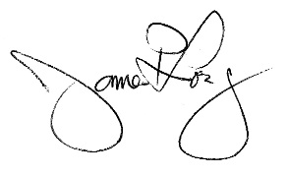
Sincerely,
Jim Long
President

Cc:
Jenifer Huff, Jenifer.Huff@erm.com
Clive Graham, clive.graham@erm.com

References:

ACOE, 2001. Letter to Senator Sarbanes from Lt. Colonel Gregory Stinner, Army Corps of Engineers, Baltimore District, July 20, 2001.

ACOE, 2003. Mattawoman Creek Watershed Management Plan, U.S. Army Corps of Engineers, Baltimore District (2003). http://www.charlescountymd.gov/sites/default/files/pgm/planning/mattawoman_management_plan.pdf

ACOE, 2008. Letter to Melvin Beall, Charles County Planning and Growth Management, from William Seib, Chief, Regulatory Branch, U.S. Army Corps of Engineers, Baltimore District, dated November 19, 2008.

Audubon, 2002. Forest bird breeding densities in Chapman’s Forest, George B. Wilmot, Southern Maryland Audubon Soc. (November 15, 2001). In Appendix II to the Chapman’s Forest Land Unit Plan, Maryland Department of Natural Resources, Resource Planning Program, December 2002.

Audubon, 2010. Maryland Important Bird Areas, Audubon Maryland-DC. http://md.audubon.org/ibas-maryland The Mattawoman IBA was dedicated in 2010.

BioNet, 2012. Biodiversity conservation network, Wildife and Heritage Service, Maryland Department of Natural Resources (2012). www.dnr.state.md.us/wildlife/Plants_Wildlife/pdfs/BIONET_FactSheet.pdf

Budget, 2015. Charles County Budget Book, July 1, 2014-June 30, 2015. http://www.charlescountymd.gov/sites/default/files/fas/budget/budgetbooks/2015/FY15_budget_book.pdf

DNR, 1975. J. O’Dell., et al., 1975. Survey of anadromous fish spawning areas-Completion Report, Fisheries Administration, Maryland DNR, Annapolis.

DNR, 2007. Mattawoman Creek Stream Valley Delineation, Anne Hong, Sean Smith, and Ken Yetman, Maryland Department of Natural Resources, 2007. Map available at: http://www.charlescountymd.gov/sites/default/files/pgm/rim/Mattawoman%20Stream%20Valley.pdf

DNR, 2010. Chesapeake Bay Finfish/Habitat Investigations, Project 3, Job 1: Fisheries and habitat interactions project: Development of habitat –based reference points for Chesapeake Bay fishes of special concern: Impervious surface as a test case-2009, MD Dept. Natural Resources, Report F-61-R-5. http://www.dnr.state.md.us/irc/docs/00015592.pdf

DNR, 2011. Performance Report For Federal Aid Grant F-63-R, Segment 2, 2011: Marine And Estuarine Finfish Ecological And Habitat Investigations, Maryland Department of Natural Resources Fisheries Service, Annapolis, Maryland. www.dnr.state.md.us/fisheries/fhep/pdf/Final2011.pdf

DNR, 2013 Performance report for federal aid grant F-63-R, Segment 4: Marine and estuarine finfish ecological and habitat investigations, Maryland Department of Natural Resources Fisheries Service (2013) http://www.dnr.state.md.us/fisheries/fhep/pdf/2013_FHEP_Annual_Report.pdf

ERM, 2011a. Land Use Market Supply and Demand Analysis, Technical Memorandum, prepared for the 2012 comp plan revision by ERM and S.S. Fuller and L.A. Sturtevant of the Center for Regional Analysis, George Mason Univ. (2011). www.charlescountyplan.org/images/document_library/LU_Market_Demand_Analysis_Technical_Memo.pdf

ERM, 2011b. ERM, 2011. Charles County Comprehensive Plan, Comprehensive Plan Scenario Evaluations, available at http://www.charlescountyplan.org/document-library, prepared by ERM, Inc, October 2011. http://www.charlescountyplan.org/images/document_library/comprehensive%20plan%20scenario%20evaluations%20rev2.pdf

ERM, 2015. Maryland Airport Land Use Study, Public Meeting and Open House, slides presented by ERM and RKG Associates, Indian Head Pavilion, January 14, 2015. www.charlescountymd.gov/sites/default/files/pgm/planning/mdair_pres1-14-15reduced.pdf

Fermata, 2000. Nature and Experiential Tourism: Report and Recommendations for Charles County, MD, Fermata, Inc., Austin TX, October 20, 2000. http://www.fs.fed.us/recreation/programs/tourism/charles_county.pdf

JLL, 2014. Indian Head Science and Technology Park, Market Analysis and Due Diligence Services, prepared by JLL, Inc. for Charles County, October 2, 2014. http://www.boarddocs.com/md/chrlsco/Board.nsf/files/9QTUSD4E36B0/$file/IHTP%20Report%20FINAL.pdf

JLUS, 2014a. Minutes of the Policy Committee leading the Joint Land Use Study for the Naval Support Facility, Indian Head (September 26, 2014). http://www.indianheadjlus.com/documents/09262014_IHJLUS_PC%20MeetingMinutes_FINAL.docx

JLUS, 2014b. Minutes of the Technical Advisory Group advising the Joint Land Use Study for the Naval Support Facility, Indian Head (May, 19, 2014). http://www.indianheadjlus.com/documents/05192014_IHJLUS_MeetingMinutes_FINAL.pdf

FWS, 2006. A GAP analysis of animal species distributions in Maryland, Delaware, and New Jersey, Final Report-Part 2. McCorkle, R.C., J.N. Gorham, and D.A. Rasberry. U.S. Fish & Wildlife Service, Delaware Bay Estuary Project, and USGS Biological Resources Division, Gap Analysis Program (2006).
http://www.fws.gov/delawarebay/Pdfs/finalreport.pdf

FWS, 2010. Letter to Candice Quinn Kelly, President of the Board of Commissioners, from Genevieve Larouche, Supervisor, U.S. Fish and Wildlife Service, Chesapeake Bay Office (January 14, 2013).

Independent, 1998. Hoyer supports gov.’s plan to preserve Chapman’s, by Rob Terry, Maryland Independent (July 3, 1998).

Independent, 2013. P.G. casino could quadruple flights to Charles’ Maryland Airport, by J. Newman, Maryland Independent (April 5, 2013).

Independent, 2015. Green, business groups face off over airport study, Maryland Independent, by Rebecca Barnabi, January 16, 2015.

MAA, 2008. Aviation System Plan, Maryland Aviation Administration (2008).

MAA, 2013. Maryland Economic Impact of Airports, Final Report, prepared for the Maryland Aviation Administration (2013). www.nbaa.org/advocacy/issues/essential/MD_2012_Economic_Impact_Study.pdf

MWS, 2000. Icthyoplankton sampling of anadromous fish usage in Mattawoman Creek, one of its unnamed tributaries draining Chapman Forest, and Reeder Run: Spring 1999, J. Long, filed under Maryland DNR under permit #SCP-99042.

NMFS, 2001. Letter from John Nichols, National Marine Fisheries Service, to Rich Bulavinetz, ACOE, Baltimore District dated Oct. 12, 2001; included in the Environmental Assessment [EA, 2002].

NPS, 2001. Letter from Wink Hastings, National Park Service, to Maria Stevens, FAA, dated June 29, 2001; included in the Environmental Assessment [EA, 2002].

RFP, 2013. Request for Proposals: Airport Land Use Study, RFP 14-28, December 3, 2013. www.charlescounty.org/webdocs/fs/bidboard/Solicitation293/131203%20-%20RFP%2014-28%20-%20Airport%20Land%20Use%20Study%20-%20Final.pdf
www.charlescountymd.gov/sites/default/files/pgm/planning/mdair_pres1-14-15reduced.pdf

RCD, 2010. http://www.somdrcd.org/articles/publish/news/Indian_Head_Works_Toward_Becoming_a_Trail_Town.shtml

RT, 2014. Some reviews of the Rail Trail are available at http://www.traillink.com/trail/indian-head-rail-trail.aspx

ULI, 2012. Technical Assistance Panel Report, Indian Head Rail Trail, Urban Land Institute, Bethesda, MD. (May, 2012) http://washington.uli.org/wp-content/uploads/sites/56/2011/06/Indian-Head-Final-Report-Draft.pdf

Weber, 2007. Ecosystem services in Cecil County’s Green Infrastructure: Technical Report for the Cecil County Green Infrastructure Plan, Ted Weber, The Conservation Fund. (2007) http://www.ccgov.org/uploads/PlanningAndZoning/General/CecilCoMD_TechReport%20-%20Ecosystem%20services.pdf

WRR. Interactive online-mapping of the WRR analysis of landscape attributes at: http://mesgisservices.com/SHA_WRR/wrr/Default.aspx
Based on a study originally published in 2012: Integrating Priorities and Achieving a Sustainable Watershed Using the Watershed Resources Registry in the Mattawoman Creek Watershed, Karin Bencala, Interstate Commission on the Potomac River Basin, Report 11-3, August 2011

Stream-health data included in this document were provided by the Maryland DNR Monitoring and Non-tidal Assessment Division. Interpretation is the of MWS.
Tale of Two Streams, http://www.mattawomanwatershedsociety.org/tale-of-two-streams
See hub-forest description at www.dnr.state.md.us/greenways/gi/overview/overview.html
Our analysis of Table 2 in the MAA economic report excludes the largest airports, i.e, we consider those with direct jobs up to 211. Including larger airports raises the inferred revenue by only 10%.
In the words of a previous pro-development vice-chair of the Charles County Planning Commission.

